**REAL-TIME DATA ACQUISITION FOR FORCE COGNITIVE AGENT-BASED MODEL IN CROWD SIMULATION**

**1. Introduction**

Crowd is not simply the gathering of large individuals. The behaviour of an individual could be affected by others which may depend on physiological and social factors. Crowd structure could vary from well-organized state to unstructured state. It is caused by people inside the crowd varying psychological characteristics from controllable state to panic condition and likely become selfish animals. Collected evidences on crowd disaster are also increasing as the time goes by. Thus, crowd study has been invented to help us understand and perform insights of crowd phenomena. It was begun on 1970s and developed from physics knowledge and biology. Since then, the field has been studied comprehensively on both of micro and macro levels. Fluid dynamics and Newton Rule. Nowadays, this research has attracted more studies because its essential importance for:

* Quantitatively investigate evacuation dynamics *(show publication)*
* Assess public facilities to understand how the design of the different infrastructure affects the flow of pedestrians. *(show publication)*
* Simply gain more knowledge about how pedestrians interact with each other and for game to simulate realistic physical forces. *(show publication)*
* Relationship human and biology *(show publication)*
* Find parameters to monitor crowd behaviour in both of micro and macro levels. *(show publication)*

In crowd modelling, two main aspects including micro and macro levels have been studied widely. Micro model aims to, macro model aims to … . In this study, we focus on micro level to understands and generate effective evacuation plan for individuals. In micro model, two popular models are social force and CA models. The model describes pedestrian’s acceleration at time *t* affected by three forces including driving force, interaction force, and the force coming from obstacles. These motion formulas are applied entirely to individuals in simulation environment for reproducing specific crowd behaviors by physical parameters over the time. However, human has different perception and knowledge and force effect from each others when making movement decision even in the same situation, and it may vary in different moments.

Contrary to force-based model focusing on movement behavior of the individuals, agent-based model pays attention on the decision making process of agents. Autonomous agents have their own attributes and could be comparable to a real person in simulation environment. Belief-Desire-Intention (BDI) agent is considered as the first effort (Georgeff, 1989). This model’s main properties are:

* Reflects how agent interact with the virtual world and makes differently decisions based on perception
* Describe agent’s own character and abilities so that the crowd simulation is heterogonous.

Thus, this model has advantage on individual heterogeneity and communicability. Agent-based model was considered for computational burden during long decades. However, with significant increase of computational processors, the issue becomes less important recently (Sun, 2014, Zhong 2014). Take advantage of above two models, several studies have combined them to simulate “more realistic” crowd behavior. A chronological survey up to latest studies on this trend is analyzed as follows:

(Helbing, 1995 & Helbing 2000 & Helbing 2014), normal, new physiological factors, only interaction in high-density crowd.

(Braun,2003) Simulate virtual crowds in emergency situations

(Pelechano,2006) leader role into a crowd and showed that the crowd could have different group patterns. (Shendarkar,2008) policemen could affect the choices of escape routes by individuals during fire excavations. Group behaviours of a crowd based on social psychology findings. It has been found that individuals could lose their individualities and adapt their behaviours to those of the whole crowd. Consensus decision making in human behavior (Couzin, 2011).

(Xi, 2010), An integrated Pedestrian Behaviour Model Based on Extend Decision Field Theory and Social Force Model to avoid directions having high density in simple infrastructure layout. Each direction differs a 45-degree angle.

(Moussaid, 2010, 2011) How simple rules determine pedestrian behavior and crowd disasters. cognitive + heuristical rules. The walking behavior of pedestrian social groups and its impact on crowd dynamic

(Sun, 2014) A Configurable Agent-Based Crowd Model with Generic Behavior Effect Representation Mechanism. His thesis A Generic Approach to Modelling Individual Behaviours in Crowd Simulation. (Reynon, 1989) and could be extend to 18 human behaviours.

(Collins, 2014), Do group matter? An agent-based modelling approach to pedestrian egress

(Kountouriotis, 2014), An agent-based crowd behaviour model for real-time crowd behaviour simulation.

(Wagoum, 2013), given set of fixed route choices option, agents has ability to choose, it measures agent’s current velocity with velocities of others on forward direction.

**Questions**

**What actual data has been collected for simulating real actual crowd modelling towards understanding crowd on micro and macro level at real-time?**

**What else can oppose? (pedestrian type-effect of agent paramaters in force model, cognitive memory route choice). how it can be enhance the model when simulating real-time? How to collect and manage real-time? How to create evacuate plan based on the model?**

However, current force cognitive agent-based models have limitations about:

1.Modelling human decision making for route choice based on cognitive agent-based model.

Current force-based agent model’s capability aims at producing heterogeneous agents with different characteristic (role), physical attributes (maximum speed, sight ranges, desired distances from other agents, obstacles) and crowd dynamics (motion flows, self-organization phenomena). However, in the latest survey on crowd simulation research field (Hoodgendoorn, 2013), force-based models (Helbing, 1997) are recommended at sufficiently simulating individual’s interaction but underestimated when they could not perform pedestrian motion decisions in route choice. Therefore, the studies on this model could not broaden for simulating decision making process, particularly at ‘why’ and ‘how’ a route choice behavior is chosen in that situation.

A previous study of the same author (Hoogendoorn, 2002) pointed that human decision making takes place simultaneously at three levels including strategic, tactical, and operational levels. Strategic level is exposed when a pedestrian select his best-planned route among the collection of options leading to a known destination, re-routing adaptively into faster routes in case of congestion or high densities. The selected route could be the shortest or most familiar paths in pedestrian’s mental map. Tactical level represents the capability towards avoiding collision, obstacles. The latter takes place by basic rules of motion (accelerating, decelerating, stopping). Human’s decision making for route choice is made by the perception of all senses including vision, sound, and cognitive process (experience and social influence).

Gaining new decision for route choice has been **considered on biological studies**. On fishing school for route choice study (Couzin, 2013) for understanding collective decision making, e. Individuals have to balance personal information (their own pass experience), potentially conflicting social information, and group cohesion to minimize isolation risk. On ant study for route choice, (Loreto ,2013) ants trade off local route choice by longer routes that could be faster. By four month experiment, the author realizes that ants select more bridge trails (structured by twigs and lianas using these bridges as part of the trail) than keeping forest floor trail choice.

**Inspired by cognitive level**, (Wijermans, 2013), CROSS: Modelling an architecture for simulating Crowd Behaviour with Social-Cognitive Agents. It imitaties conceptually how agent’s cognition works in specific scenario by predefined and unchangeable behaviour rules, facts from psychological and social demands.

Inspired by aspects on s**tudying Agent-based Modelling and Evacuation Plan** (Zhan, Chen 2006)

Current human behavior models lack the simulation ability on human’s experience (familiarity) for route choice decision making. Agent’s experience could be adopted autonomously and learned from surrounding environment and other agents over the time which means new facts could be self-created and used adaptively (e.g. mental map is updated adaptively when the agent explores new infrastructure or the map could be shared for those who are the same room, agent’s friend number increase when the agent visits more at one infrastructure). Current crowd simulation models only simulate agents with one evacuation route and once the route is not satisfied he can then stop or use fixed other route. However, these information must be perceived over a period. During that period, a decision making is given by their accumulated knowledge.

Thus, in this study we prefer to explore how agent’s cognition is updated over the time to give adaptively new decisions on route choice behavior. To scrutinize this problem, we define below gaps for this research direction.

* What influent agent’s route choice levels. (current crowd context, several papers working on crowd density on forward direction, correlation on velocity on boundary to giving decision rules, physiological demand -bladder and stomach, roles and communication, personal physical attributes, experience )
* How to model new knowledge extracted from observed facts for agent’ s cognitive level.
* How to simulate the impact of agent’s perception on route choice behaviour.
* How does the agent’s accumulated knowledge affect evacuation plan.

2.Measuring effects of agent’s parameters.

Inspired by (Sun,2014) and (Wijermans, 2013), in agent-based model, the one clearest limitation is no standard mechanism to validate the effects of agents’ parameters in the forces’ calculation formulas and agent’s facts. It must collect these information practically via camera or mobile sensing information to validate and update the models.

The data from mobile makes human identifiable while traditional models mainly collect data from camera and thus human is interchangeable in the same video scene:

-(Johansson, 2007) calibrated social-force model’s parameters by evolutionary optimization algorithm. This work is performed by manual analytic on video recordings of pedestrian crowds in Germany. Desired speed is determined by maximum speed of each captured pedestrian.

-(Moore, 2011) hydrodynamic lens used average velocity to derive repulsive force for agents and compare manually with previous values to detect abnormal. The study also tracks pedestrian’s trajectory by balancing relevant factors.

-(Wagoum, 2013) used cameras designated at a stadium’s corridors and stands with embedded density detection software to monitor real-time crowd movement.

-(Daamen and Hoogendoorn, 2012) and (Ko, 2013) calibrated social force model by the maximum log-likelihood estimation method to describe parameters in statistic ways.

-(Zeng, 2014) used camera to capture pedestrian in cross way at traffic lights. The social force model is revised by add the force for avoiding vehicles and crosswalks boundary. The study also separated the model’s parameters to measurable and unmeasurable arguments for calibration by using log-likelihood estimation.

Other limitations of camera approach also include occlusion, shape changes (larger when closer to camera), limited capturing range. They obstruct and shape traditional models with poor capacities at capturing density and exploring information on fixed scenes rather than analysing how and why a behavior is chosen. To scrutinize this problem, we define below gaps for this research direction

* Which data can be collected from video and mobile phone to supply proposed model?
* How to collect this data technically and socially?
* How these information can help to define evacuation plan for each agent?. mobile as data supplement for centralized server to detect route ACO and return evacuation plan for agent.

The aims of this research study include:

1. Build a force agent-based model to simulate adaptive route choice behaviour based on agent’s cognitive level.
2. Explore novel collectable data from mobile and camera for crowd modelling metrics.
3. Explore effective optimization techniques to create evacuation plan based on agents’ knowledge and current data.

The importance and contribution of this study:

**For evacuation plan**

* It helps to explore factors that affect agent’s route decision making behaviour and their usefulness for evacuation plan. The behaviour must balance the relationship between knowledge and current surrounding environment information. This information also affects to general evacuation plan to indicate potential obstacles. Understanding which route an agent will choose in the case of congestion based on his experience. Knowing potential congestions when agents detour. Create evacuation plan for each agent effectively by minimizing evacuation time and potential hazard.
* By collected data from actual pedestrian for cognitive agent-model, it’s able to test with different infrastructure layout and different crowd dynamics. With this simulation model, we offer a new validation approach to check whether different infrastructure layouts are suitable for actual collected agent’s characteristic.

**For crowd modelling validation**

* It provides a new validatable model to simulate and identify desired route for agents. It’s testable with actual pedestrian data from both of camera and mobile. This is a novel approach to broaden crowd simulation models when newly using mobile phone data.

**For crowd research community**

* For crowd research community, this study offers a comprehensive dataset towards understanding crowd context over a period by both of mobile and camera data. It motivates further studies for exploring new crowd dynamics, monitoring purpose, and for evacuation plan.

**2. Literature Review**

Each model in this chronological literature review is represented, and evaluate advantages and limitations.

**2.1 Simulate virtual crowds in emergency situations** (Braun, 2003)

**2.2 Crowd Simulation Incorporating Agent Psychological Models, Roles, Communication** (Pelecheno, 2006)

Main aim is to Combine her own model (MACES) with another physiological model (PMFserv) to simulate current agents more realistically by emotional states (stress, fatigue, injury).

**-**This model simulates behaviour of people who have different roles in evacuation situation to understand how they can go to Exit gate of a building. Simulated environment is constructed by corridors, individual rooms. Each room has its own exit door’s position. Each room has the shortest path towards the Exit gate. Each agent has specific role (trained leader, untrained leader, or follower)

•Trained Leader: knows building’s internal structure and he is eligible to know the path towards Exit gate from the room he is in.

•Untrained Leader: helps other people and explores the building for new paths

•Follower: follow the leader in the same room

-Each agent also has a mental map of building when he explores the building (arc: corridor, node: room).

-People who are the same room will use Helbing’s interaction force to move to predefined exit Door of the room.

•Advantage: Perform various roles and communicability by sharing mental map. People who are the same room can share their map.

•Limitation:

–This model only calls APIs of physiological model to simulate colourfully current emotional state of agents. It lacks the mechanism to simulate how external environment impacts on his physiological attribute.

– It didn’t integrate individual’s characteristic in agent information. Because the reaction behaviour of agent must satisfy agent’s attribute.

•Individual’s characteristic: sight range, walking speed, desired distance from each other, minimum distance from each other, maximum desired distance from obstacles, …

Since 2006, several other studies also follow this trend to explore the impact of different roles on human behaviour. (Shendarkar,2008) simulates policemen could affect the choices of escape routes by individuals during fire excavations. People could lost their individualities and adopt the behaviour of stimulus group (Couzin, 2011).

**2.2 An integrated Pedestrian Behaviour Model Based on Extend Decision Field Theory and Social Force Model** (Xi, 2010)

In social force model (Helbing, 2000) in panic condition, pedestrian’s acceleration at time *t* is affected by three forces including driving force, interaction force combined by physical and psychological forces, and the force coming from obstacles. The author, (Xi, 2010), revised interaction force with two assumptions. First, physical force only occurs in a specific connection range. Second, psychological force is distinguished for whether pedestrians are group members. The core component in Xi’s pedestrian model is a decision making function mimicking human deliberation process. Choosing which direction to go forward in each state relies on previous state’s information and current crowd density on each forward visual direction. One pedestrian is assumed to have six forward directions. (Left, LeftFront, Front, FrontRight, Right, Back). Xi’s model is studied on a shopping mall case study. Given a plan of desired shops, an agent X’s behavior is described at:

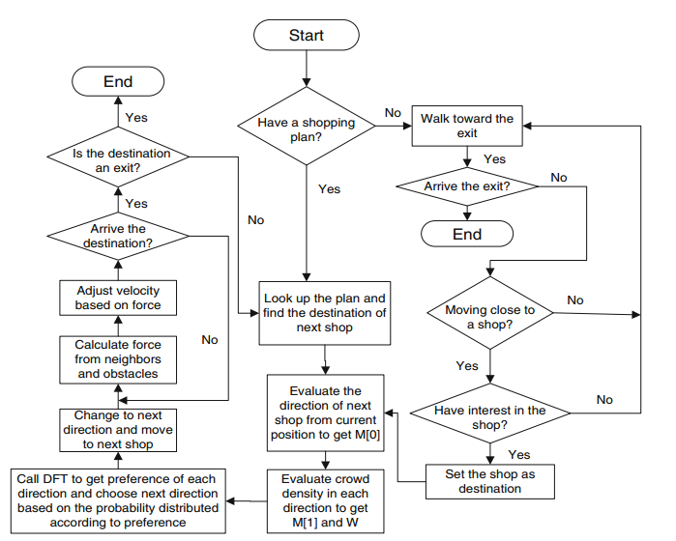

**Step1:** Look up the plan and find the destination of next shop

**Step2:** Evaluate the route going to the shop location from current position

**Step3:** Compute density on each of six forward directions on that route

**Step4:** Perform decision making function to select best direction based on crowd density values

**Step5: While (current position != shop location)**

For each forward direction

For each agent j $ϵ$*K* agents on that direction

Interaction force += Psychological force of X and *j*

**If** dXj < *predefined constant* *Connection Range*

Interaction force += Physical force between X and *j*

End if

End for

End for

Adjust agent velocity from computed forces and move

**End While**

With constant connection range, it leads to a high computation when setting large values. Moreover, it’s still difficult to validate connection range in practical. Checking psychological force for group members is not effective when members are occluded on that direction. Using AnyLogic® tool, this study could simulate 950 agents. According local route choice, crowd density on each direction is not stable for whole the time in fact. Thus, this model couldn’t perform the ability to switch agent from current direction into a faster one if current direction has sudden crowd density increase.

In fact, human is sensitive when making movement decision even in high-dense crowd flow. The decision is made by the perception of all senses including vision, sound, experience and social influence. This action takes place simultaneously at different three levels including strategic (global route choice), tactical (local route choice), and operational levels (Hoogendoorn, 2002) . Xi’s model only performs basic strategic level (planning which shops to stop by in initial plan) and a part of local route choice level (picking up initial direction to go without switching to another route if necessary). Moreover, in fact, pedestrian only moves with high acceleration when he know there is having more space in forward direction (Moussaid, 2010).

Thus, we revise Xi’s model to achieve less computation and more adaptable in local route choice with the new flock-based approach. A pedestrian flock F is a moving cluster that exists in a *duration* and consist more than *n* pedestrians. An agent X’s behavior is described as follows:

**Step1:** Look up the plan and find the destination of next shop

**Step2:** Evaluate the route going to that shop location from current position

**Step3: While (X’s current position != shop location)**

Identify ***forward flock***

**For each forward flock**

**-** Identify *Collection* ***K*** *of agents on each* ***flock’s boundary***

**-** Computeaverage distance between agents in **K**

Eliminate direction on flock having the shortest distances between its boundary agents.

Identify **X**’s ***current flock*** **M** and *collection* ***I*** *of agents on the boundary of* ***M***

If **X $ϵ$** *I*

For each agent *j $ϵ$* *K*

Compute psychological force of **X** and ***j***

Endfor

End if

Compute physical force of X and agents $ϵ$***M***

Adjust agent velocity from computed forces and move

**End while**

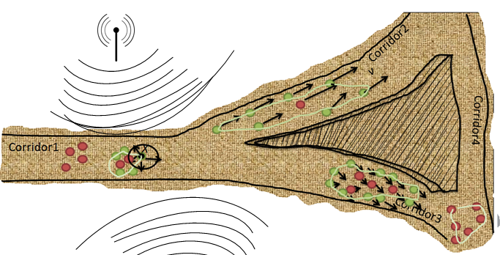

**Figure 1**. Example of proposed method. Flocks are clustered by green line. Green agents are on flock’s boundary. In this scenario, there has five flocks.

**For local route choice enhancement:** The key idea in this proposed model performs at:

1. If agents at the boundary of forward flocks are close together, current agent will avoid that flock. This will guarantee local route choice
2. We only calculate psychological force for each agent with the other agents at forward flock’s boundary.

The Xi’s model is the first aim to use human decision theory for reflecting human thinking. However, forward direction is divided to fixed 45 degree difference and therefore it can’t help to re-route on other corridor for human adaptive mental map and communicability among agents.

**2.3 A Configurable Agent-Based Crowd Model with Generic Behavior Effect Representation Mechanism** (Sun, 2014)

This study aims to create heterogeneous agents with different physical attributes (body size, maximum speed, average speed, movement speed adjuster, sight range, sense range for group behavior). This study try to simulate human perception by principles that during decision making process, behavior affect impacts differently to each agent, agent’s new reaction must reflect and satisfy personal attributes, and environment (not touch wall, obstacles) or other agent’s position. This model is developed on Microsoft XNA framework.

Inspired from behavior effect of (Reynolds, 1987) to determine movement of artificial agents,

**next position** = **current position** + **Behavior effect causing displacement**

in which, behavior effect is a vector has the strength magnitude and direction, performing how far an agent will move, and in which direction, respectively.

When receiving a force , object receive an acceleration to have a new speed after 



the displacement after  will be



thus,



When Δt is small (1/60 second), agent’s speed during Δt can be considered constant averagely



This study brings a new united formula for all behavior effect from a set of generic parameters.



in which, ,,  are independent parameters of behaviors, their value remains the same during the calculation of behavior effects. (: Positions of target, : position of agent in 2D space,  is the effect of base speed of each agent : *s*: default walking speed of the agent, u: unit scale in simulation environment: (1 pixel = 0.05 metre, r: denotes frame rate of simulation engine )

: scalar value, self factor reflects the agent’s own desire on each behavior- run away or walking away; : impact of the target on the agent,  distance factor, e.g repulsive effect less when distance more.***Desired speed = his average speed * behaviour effect.***The agent model is performed as Figure 2.

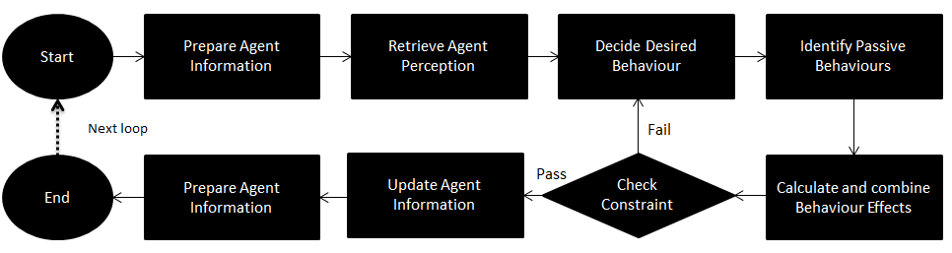

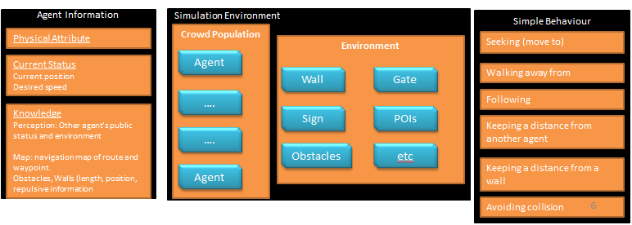

**Figure 2**. Force agent-based model

Picking one of following behaviour and compute behaviour effects between them and test whether behaviour satisfies environment obstacles. A library that consists of a set of predefined rules (behaviours), which determine how an agent will act under certain situations. Several behaviors are proposed in this library as follows:

-Seeking (move to):

-Walking away from:

-Following:

-Keeping a distance from another agent

-Keeping a distance from a wall

-Avoiding collision

-Walking towards the group

-Keeping in a Group combines Walking towards the group and aligning direction with the group

Each behavior is derived by its own formula to compute behavior effect based on the original formula.

Passive behavior effect is also derived from the formula for repulsive force as Helbing’s force-based model for other agents and obstacles, walls. To simplify, it computes the repulsive effect from nearby crowd.

An actual scenario (i.e, two people walking in one corridor, ) is interpreted into list of phases, each phase also is interpreted into above library that is the list of simple behaviors such as:

**Phase 1**: **Start Walking -> Before Catching up**. They only perform walk to the east end of the corridor $→$ Seeking (Move to)

**Phase 2: Catching up -> Overtaking -> Overtaken**

Catch up, they only perform walk to the east end of the corridor $→$ Seeking (Move to)

Overtaking, one pedestrian could affected by three forces:

Walk to the east end of the corridor $→$ Seeking (Move to)

Keep a desired distance from sidewall $→$ Keep a distance from wall

Avoid collision with others $→$ Keep a distance from other agents

The strongest points of this model are configurability for agent’s attributes and extensibility on behavior libraries. However, it still lacks of decision making ability on route choice levels and cognitive theory that could be adapted and changed over a period. Moreover, it can not perform agents overlayed (i.e stampede, turbulence).

**2.4 CROSS: Modelling Crowd Behavior with Social-Cognitive Agents (Wijermans, 2013)**

CROSS (modelling Crowd behavior in a Simulation with Situated individuals). This study proposes a generic cognitive architecture of agent for designing and exploring any model to simulate crowd behaviour. A cognitive architecture describes internal components and mental processes of an individual to give a behaviour decision at any given moment in time. Current state of memory component represents knowledge.

CROSS agent simulation allows for tracing what behavior is chosen and why. In general, internal components are the place where knowledge can be changed and used by mental processes or the intercorporation of themselves. Mental processes comprise perception and behavior selection allow agent interact with surrounding environment via perceiving and reacting. The cognitive architecture of CROSS agent is illustrated in Figure 3.

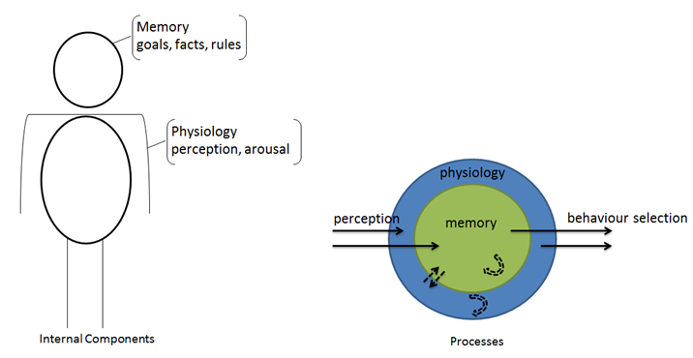

**Figure 3**. Cognitive architecture of CROSS agents based on concepts: Physiology structure of recognition (Newell, 1990) and Memory architecture (Anderson, 2007)

Physiology represents the structure of cognition. It involves the most essential physiological factors influencing crowd behaviors: perception and arousal. Perception implies explicit information human senses can aware by human sensors (eye, nose, ear). Each human also has sensing limitation such as vision range, hearable sound frequency. Arousal component involves behaviors that alert/warn people automatically for surviving purpose (i.e. a time limitation is set to automatically warn human have to feed, or go to restroom).

The memory component in this study comprises the network of elements (goal, fact, or rule). Each element has content and activation level of itself. The activation level reflects how this memory element affect behaviour. Both of content and activation level could be changed over the time.

Goal element:

This element represents the state an individual desire, making a particular behaviour become more or less relevant to choose. Four goals in this study are:

-Subsistence: means preserving energy

-Safety: means remaining safe

-Social: means belonging to a group

-Personal goal: enjoy or do something individually

The activation level of this element is Goal dominance. It expresses that a chosen behaviour satisfy that goal. (i.e, safety goal is most dominant, because the agent is in a crowded place, then behaviour ‘walking away’ will be chosen. The goal dominance is calculated as the result when the preferred level of satisfaction subject to the actual satisfaction of that goal.

Fact element

This element assists an agent in interpreting information from perception process. Facts has three types: area fact (help to recognise POI), personal fact (help to recognize friends, other people), behavior fact (convey expectation values of satisfaction it would be to perform a particular behavior).

The activation level of this element is related to the time it takes to retrieve a fact from memory. Facts with high activation level are easily retrievable. The activation value of facts is calculated by a neuron activation equation. This equation aims to increase the activation value of the memory elements that are primed to be more probable or relevant to happen at that moment.

Rule element

Behaviour rules allow an agent to exhibit specific behaviour. The activation value give a rise to a dynamical hierarchy in behavior an agent knows. The changes in activation over time result in a dynamic ordering of behaviours in which behaviour will be selected before execution.

Processes comprise perception and behaviour selection.

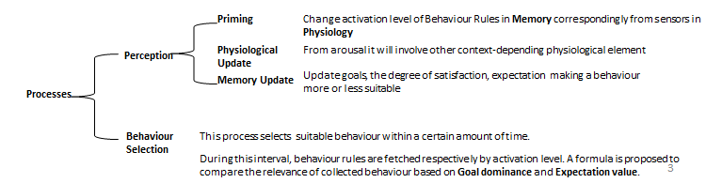

**Figure 4**. Processes in Social Cognitive agent-based Model (Wijermans, 2013)

-This framework is developed by Repast Simphony agent-based framework (Java-based). This framework is studied for a Party case study.

-In Physiological:

-Ticker time to go to toilet

-Ticker time for eating

-Toilet, and eating positions are in POIs of agents

-In Cognitive architecture of an agent:

-Memory:

-Goals: safety, social, individual, or subsistence to satisfy Physiological factors

-Fact: Area fact (recognise POIs), personal fact (friends, leaders). Behaviour fact let us know expectation it would be to perform a particular behaviour

-Behaviour Rules: for walking, running, dancing

-Process:

-Perception:

-physiological update: detect density, arousal alert in 1000 ticks

-Memory update: update Goal dominance for goals from physiological update.

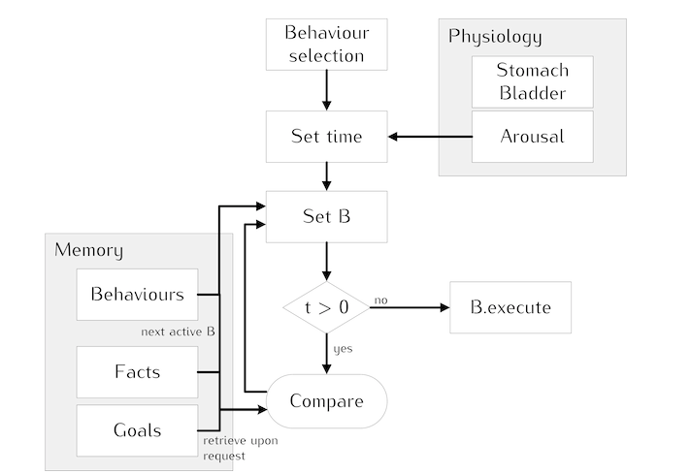

**Figure 5**. Processes in Social Cognitive agent-based Model (Wijermans, 2013)

Advantage:

* Propose a well-organized generic framework to integrate cognitive architecture How people thinking and why a behaviour is chosen by internal process.
* Each situation could be defined with other factors for physiology and memory element

Limitation:

Behavior selection process in CROSS model only offers the ability to identify goal and its behavior rule that are satisfied current physiological demand. Cognitive level is predefined and unchanged in CROSS model.

**2.5 Route Choice Modelling and Runtime Optimisation for Simulation of Building Evacuation (Wagoum, 2013)**

This study present route choice modelling based on shortest path, global path for human decision route behaviour, however these information are assumed to be pre-known for whole agents.

**3. Propose Approach for Adaptive route choice behavior (when does an agent need to re-route, when does agent need to decelerate)**

-What are the key idea to open the door, and why is it resolvable.

(Reynolds, 1999) proposed eighteen behavior in games

Simulation scenarios for temporal decision making of agent A in two corridor environment:

**Scenario 1**: Agent A sees another agent B in forward direction in the same corridor 1, he takes over and reach exit. Agent A will put info agent B in his memory, update new possibly acceleration in knowledge and estimated time.

**Scenario 2**: Agent A see another group of two agents C,D in forward direction in the same corridor 1, all rules can not satisfy him, he decelerates and follows agents C,D to exit the corridor. Agent A will put info agent C,D in his memory

**Scenario 3**: Agent A starts and go to corridor 2 and face exit gate. Agent A put corridor 2 to exit gate into his memory.

**Scenario 4**: Agent A see agent B again by checking his memory, he keep a closer distance to agent B and go to exit gate together

**Scenario 5**: Agent A see another group of two agents C,D. When rule is not satisfy, he use knowledge, it’s still not successful, he select corridor 2.

Self learning will auto put new knowledge learned from observed phenomena into knowledge component. Knowledge component will remember threshold and which people should follow. Memory remembers threshold for situation and update threshold if the result is fail comparing planned route and duration. Memory save other people’s information with a hierarchical tree information.

personal characters (leadership, willingness to follow, stay in a group, being affected by points of interest, desired distance from each other, desired distance from obstacles)

**4. Research Methodology**

**Research Framework**

**4.1 Force agent-based model simulation**

Using BonnMotion software to generate agent’s mobility.

Crowd Dynamics Myriad II to perform. OpenCL

Repast Simphony

**4.2 Data Collection Infrastructure**

Using mobile framework of Android Sensor Manager Library published by Cambridge to develop.

**4.3 Social Deployment**

**A shopping mall case study**

When shoppers come to the area. They will invited to answer the survey about their habit, items they intend to buy, gender. A mobile application is then recommended to download and registered with the predefined ID on the survey. They will register account via the app and allow to turn on Bluetooth, Wifi and accelerometer sensors. The application has several main functions to attract shoppers include:

- Show current location on the map and available shops for their wanted items.

- Shop heat map density and information to connect with friends via social network if possible.

For each 5-second time window, Bluetooth sensors will scan surrounding other devices and record their MAC address. Other information including accelerometer to measure velocity and Wifi to identify current location is also transmitted into a distributed network system to perform heatmap and put information on big data architecture.

**A forum conference is deploy**

**5. Reference**

Hoogendoorn, S.P., Duive, .D.C., Daamen, W., December 2013. State-of-the-art crowd motion simulation models. *Transportation research part C*, Volume 37, Pages 193-209.

Xi, H., Son, 2010. An integrated pedestrian behavior model based on extended decision field theory and social force model. In *Winter Simulation Conference*, Pages 824-836.

Helbing, D., Farkas, I., Vicsek, T., 2000. Simulating dynamical features of escape panic. *Nature*, Pages 4487-4490

Chrabi, M., Freialdenhoven, M., Schadschneider, A., Seyfried, A., 2012. Modelling the desired direction in a force-based model for pedestrian dynamics. *Traffic and Granular Flow 2011*. Moscow.

Bandini, S., Rubagotti, F., Vizzari, G., Shimura, K., 2011b. A cellular automata based model for pedestrian and group dynamics: motivations and first experiments. In *Lecture Notes of Computational Science*, Springer.

Moussaid, M., Perozo, N., Garnier, S., Helbing, D., Theraulaz, G., 2010. The walking behavior of pedestrian social groups and its impact on crowd dynamic. *PLoS ONE* 5, e10047.

Wagoum, A. U., 2013. Route Choice Modelling and Runtime Optimisation for Simulation of Building Evacuation. *Doctoral Dissertation at University of Wuppertal*.

Johansson, A., Helbing, D., Pradyumn, K.S., 2007. Specification of the social force pedestrian model by evolutionary adjustment to video tracking data. *Advances in Complex Systems*, 10, 271-288.

Georgeff, M.P., Ingrand, F.F, 1989.Decision-Making in an Embedded Reasoning System. *International Joint Conference on Artificial Intelligence*.

Anderson, J.R, 2007. How can the Human Mind Occur in the Physical Universe. *New York: Oxford Press*.

Newell, A., 1990. Unified theories of cognition (3rd Edition),*. Cambridge: Harvard University Press*.

Couzin, 2011. Visual attention and the acquisition of information in human crowds. In *PNAS*.

Couzin, 2013. Both information and social cohesion determine collective decisions in animal groups. In *PNAS*

Loreto, 2013. Foraging ants trade off further for faster: use of natural bridges and trunk trail permanency in carpenter ants. In *Naturwissenschaften*

Wijermans*,* 2013. CROSS: Modelling Crowd Behavior with Social-Cognitive Agents. *Journal of Artificial Societies and Social Simulation*.

Pelechano, 2006. Crowd Simulation Incorporating Agent Psychological Models, Roles and Communication. *In proceeding of 1st Workshop of Crowd Simulation*.

Sun, 2014. A Configurable Agent-Based Crowd Model with Generic Behavior Effect Representation Mechanism. *Journal of Computer-Aided Civil and Infrastructure Engineering.*

Shendarkar, 2008. Crowd simulation for emergency response using BDI agents based on immersive virtual reality. *Simulation Modelling Practice and Theory,* 16(9), pp.1415–1429.

Moore, B. E., Ali, S., Mehran, R., Shah, M., 2011. Visual Crowd Surveillance through Hydrodynamics Lens. *Communications of The ACM*, (contributed paper) Vol. 54, No.12.

Daamen, W., & Hoogendoorn, S. P.,2012. Calibration of pedestrian simulation model for emergency doors for different pedestrian types. *Transportation Research Record*, 2316, 69 - 75.

Ko, M., Kim, T., & Sohn, K., 2013. Calibrating a social-force-based pedestrian walking model based on maximum likelihood estimation. *Transportation*, 40, 91 - 107.

Zeng, W., Nakamura, H., Chen, P., 2014. A Modified Social Force Model for Pedestrian Behavior Simulation at Signalized Crosswalks. In *the 9th International Conference on Traffic & Transportation Studies*, 521 – 530.